**Gateway Technical College**

DATABASES

152-080

Unit 7 Assignment

# Introduction

In this lab you will normalize an unnormalized table to the third normal form (3NF) using the bottom-up approach learned in class and the text book. You will also create a database to store the tables created and provide an Entity Relationship Diagram.

Verify that all of the tables are complete with the appropriate fields, types, lengths and any default values, keys and constraints (e.g. FK).

The following diagram is an unnormalized table of a flat file (Excel) containing the entities and attributes for this assignment.

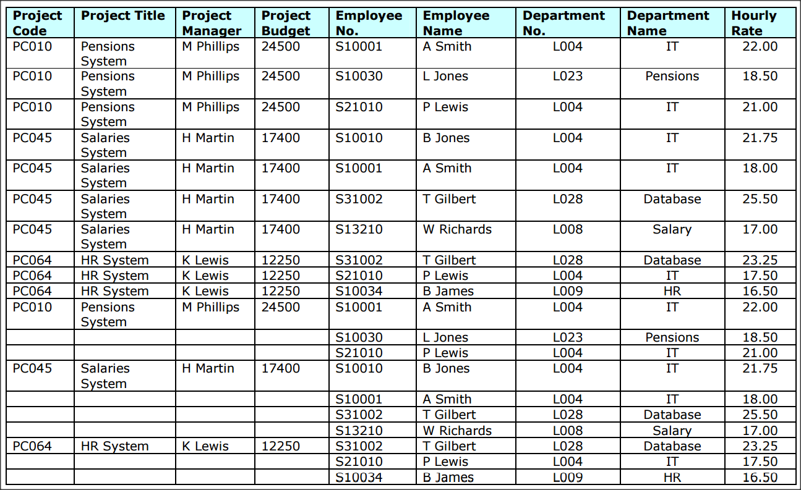

MAKE SURE document your work and your commands work before you past them into the document. Do not use the GUI interface to alter these actions.

Once completed, attach this completed word document to this assignment for grading.  Each question will be worth 20 points.

Use the **Discussion Forum** if you have any questions regarding the how to approach this assignment. You can also email your instructor directly for assistance if you have any questions.

Save your submission as ***lastnameFirstname_assign7.docx*** and submit it in the unit *Apply* section of the course.

# Instructions

You are to complete the following actions. For each question below – paste in print screens of your normalization process (tables in appropriate normal forms) and query window showing the command and the functioning output.

1. **First Normal Form (1NF)**

In this step, transform the table of unnormalized data into first normal form (1NF).

The rule is: **remove any repeating attributes to a new table**. The process is as follows:

* Identify repeating attributes.
* Remove these repeating attributes to a new table together with a **copy** of the key from the UNF table.
* Assign a key to the new table (and underline it). The key from the original unnormalized table **always** becomes **part** of the key of the new table. A **compound key** is created. The value for this key must be unique for each entity occurrence.

**YOUR TABLES IN 1NF:**

|  |
| --- |
|  |

2. **Second Normal Form (2NF)**

The next step is to transform the data in first normal form (1NF) into second normal form (2NF). The rule is:**remove any non-key attributes that only depend on part of the table key to a new table.**Ignore tables with (a) a simple key or (b) with no non-key attributes (these go straight to 2NF with no conversion). The process is as follows:

1. Take each non-key attribute in turn and ask the question: is this attribute dependent on **one part** of the key?
   * If yes, remove attribute to new table with a **copy** of the **part** of the key it is dependent upon. The key it is dependent upon becomes the key in the new table. Underline the key in this new table.
   * If no, check against other part of the key and repeat above process
   * If still no (i.e. not dependent on either part of key), keep attribute in current table.

**YOUR TABLES IN 2NF:**

|  |
| --- |
|  |

3. **Third Normal Form (3NF)**

The next step is to transform the data in second normal form (2NF) into third normal form (3NF). The rule is: **remove to a new table any non-key attributes that are more dependent on other non-key attributes than the table key**. Ignore tables with zero or only one non-key attribute (these go straight to 3NF with no conversion). The process is as follows:

* If a non-key attribute is more dependent on another non-key attribute than the table key:
  + Move the **dependent** attribute, together with a **copy** of the non-key attribute upon which it is dependent, to a new table.
  + Make the non-key attribute, upon which it is dependent, the key in the new table. Underline the key in this new table.
  + **Leave** the non-key attribute, upon which it is dependent, in the original table and mark it a **foreign key** (*).

**YOUR TABLES IN 3NF:**

|  |
| --- |
|  |

4. Complete the follow SQL commands.

* 1. Create a database called **NormalizeDB**.
  2. Create all the tables you have normalized. You’re not required to enter the data, but just the table structures and their relationships.

**YOUR COMMANDS WERE:**

|  |
| --- |
| CREATE Database ProjectInfo  Create Table Department  (  DepartmentNoID Int Not Null Primary Key,  DepartmentNo VarChar(4) Not Null,  DepartmentName VarChar(75) Not Null  )  Create Table Project  (  ProjectCodeID Int Not Null Primary Key,  ProjectCode VarChar(5) Not Null,  ProjectTitle VarChar(75) Not Null,  ProjectManagerFName Char(1) Not Null,  ProjectManagerLName VarChar(40) Not Null,  ProjectBudget Int Not Null,  )  CREATE Table Employees  (  EmployeeNo VarChar(6) Not Null Primary Key,  EmployeeFName Char(1) Not Null,  EmployeeLName VarChar(40) Not Null,  HourlyRate Int Not Null,  DepartmentNoID Int Not Null References Department(DepartmentNoID),  ProjectCodeID Int Not Null References Project(ProjectCodeID)  ) |

5. Verify that all of the tables were created correctly with the appropriate constraints and relationships. Create an ERD showing all tables and their relationships.

**YOUR VERFICATIONS:**

|  |
| --- |
|  |